Assignment 1 –

File Name – home.aspx

<%@ Page Language="C#" AutoEventWireup="true" CodeBehind="home.aspx.cs" Inherits="Assignment_1.home" %>

<!DOCTYPE html>

<html xmlns="http://www.w3.org/1999/xhtml">

<head runat="server">

<title></title>

</head>

<body>

<form id="form1" runat="server">

<div>

</div>

<p>

Enter Name :

<asp:TextBox ID="txtName" runat="server"></asp:TextBox>

<asp:RequiredFieldValidator ID="RequiredFieldValidator1" runat="server" ControlToValidate="txtName" ErrorMessage="Enter Name*">*</asp:RequiredFieldValidator>

</p>

<p>

Enter Email :

<asp:TextBox ID="txtEmail" runat="server"></asp:TextBox>

<asp:RequiredFieldValidator ID="RequiredFieldValidator2" runat="server" ControlToValidate="txtEmail" ErrorMessage="Enter Email * ">*</asp:RequiredFieldValidator>

</p>

<p>

Enter Password :

<asp:TextBox ID="txtPassword" runat="server" TextMode="Password"></asp:TextBox>

<asp:RequiredFieldValidator ID="RequiredFieldValidator3" runat="server" ControlToValidate="txtPassword" ErrorMessage="Enter Password*">*</asp:RequiredFieldValidator>

</p>

<p>

<asp:Button ID="btnLogin" runat="server" Text="Login" OnClick="btnLogin_Click" />

</p>

<asp:ValidationSummary ID="ValidationSummary1" runat="server" />

<p>

</p>

</form>

</body>

</html>

File Name – [home.aspx.cs](http://home.aspx.cs)

using System;

using System.Collections.Generic;

using System.Linq;

using System.Web;

using System.Web.UI;

using System.Web.UI.WebControls;

namespace Assignment_1

{

public partial class home : System.Web.UI.Page

{

protected void Page_Load(object sender, EventArgs e)

{

}

protected void btnLogin_Click(object sender, EventArgs e)

{

try

{

if (txtName.Text == "" || txtEmail.Text == "" || txtPassword.Text == "")

{

Response.Write("All Field Are Require");

}

else

{

Response.Cookies["name"].Value = txtName.Text;

Response.Cookies["email"].Value = txtEmail.Text;

Response.Cookies["password"].Value = txtPassword.Text;

txtName.Text = "";

txtEmail.Text = "";

txtPassword.Text = "";

Response.Redirect("login.aspx");

}

}

catch (Exception ob)

{

}

}

}

}

File Name – Login.aspx

<%@ Page Language="C#" AutoEventWireup="true" CodeBehind="login.aspx.cs" Inherits="Assignment_1.login" %>

<!DOCTYPE html>

<html xmlns="http://www.w3.org/1999/xhtml">

<head runat="server">

<title></title>

</head>

<body>

<form id="form1" runat="server">

<div>

Login Page

</div>

<p>

Enter Email :

<asp:TextBox ID="txtEmail" runat="server"></asp:TextBox>

</p>

<p>

Enter Password :

<asp:TextBox ID="txtPassword" runat="server"></asp:TextBox>

</p>

<p>

<asp:Button ID="btnLogin" runat="server" Text="Login" OnClick="btnLogin_Click" />

</p>

</form>

</body>

</html>

File Name – login.aspx.cs

using System;

using System.Collections.Generic;

using System.Linq;

using System.Web;

using System.Web.UI;

using System.Web.UI.WebControls;

namespace Assignment_1

{

public partial class login : System.Web.UI.Page

{

protected void Page_Load(object sender, EventArgs e)

{

}

protected void btnLogin_Click(object sender, EventArgs e)

{

Response.Cookies["email"].Expires = DateTime.Now.AddSeconds(1);

Response.Cookies["password"].Expires = DateTime.Now.AddSeconds(1);

if (Request.Cookies["email"].Value == "" && Request.Cookies["password"].Value == "")

{

Response.Redirect("home.aspx");

}

else if (Request.Cookies["email"].Value == txtEmail.Text && Request.Cookies["password"].Value == txtPassword.Text)

{

Response.Write("Valid User");

}

else

{

Response.Write("Invalid User");

}

}

}

}

Output –

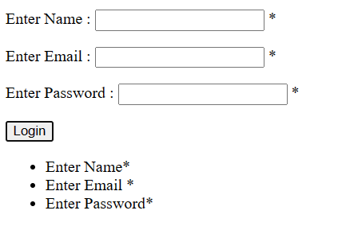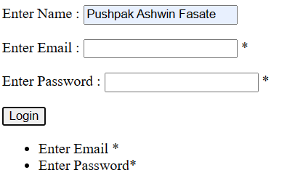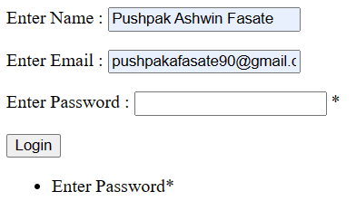

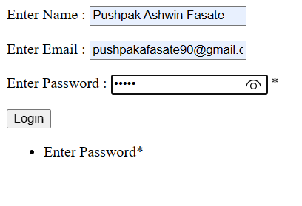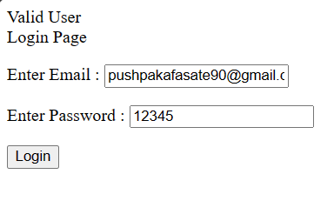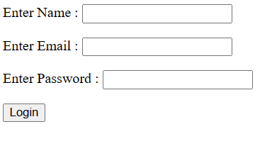

Assignment 2 –

File name – DOB.aspx

<%@ Page Language="C#" AutoEventWireup="true" CodeBehind="DOB.aspx.cs" Inherits="Assignment_2.DOB" %>

<!DOCTYPE html>

<html xmlns="http://www.w3.org/1999/xhtml">

<head runat="server">

<title></title>

</head>

<body>

<form id="form1" runat="server">

<div>

</div>

<p>

Select Date of Birth :

<asp:Calendar ID="Calendar1" runat="server"></asp:Calendar>

</p>

<p>

&nbsp;</p>

<p>

Age is :

<asp:TextBox ID="txtAge" runat="server"></asp:TextBox>

</p>

<p>

&nbsp;</p>

<p>

<asp:Button ID="btnCal" runat="server" OnClick="Button1_Click" Text="Calculate Age" />

</p>

</form>

</body>

</html>

File Name – DOB.aspx.cs

using System;

using System.Collections.Generic;

using System.Linq;

using System.Web;

using System.Web.UI;

using System.Web.UI.WebControls;

namespace Assignment_2

{

public partial class DOB : System.Web.UI.Page

{

protected void Page_Load(object sender, EventArgs e)

{

}

protected void Button1_Click(object sender, EventArgs e)

{

int select_date = int.Parse(Calendar1.SelectedDate.ToString("yyyy"));

int current_date = int.Parse(DateTime.Now.ToString("yyyy"));

int cal_age = current_date - select_date;

txtAge.Text = cal_age.ToString();

}

}

}

Output –

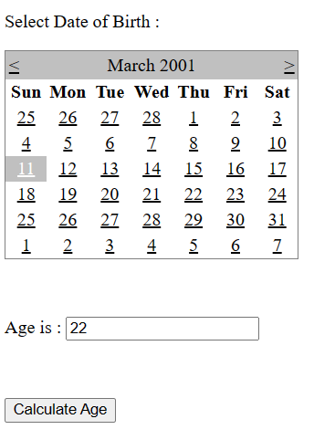

Assignment 3 –

File Name –

Output –